LAB EXPERIMENT NO # 10

Charging and Discharging of a Capacitor

Objective:

The objective of this experiment is to verify the exponential behavior of capacitors during charging and discharging processes.

Equipment:

A capacitor, a resistance box, 2 multi-meters, connecting wires, a watch, a dc power source, and a switch

Theory:

A capacitor is a passive electric device that stores electric energy. A parallel-plate capacitor is made of two parallel conductive surfaces, each of area A, separated by an insulation layer of thickness d, and it has a capacitance of
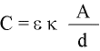
where C is the capacitance in farads, A the area of each plate in m², d the insulation (dielectric) thickness in (m), and εo the permittivity of free space (vacuum) for electric field propagation expressed in F/m.

The factor, κ , pronounced “kappa,” denotes the dielectric constant, and depends on the material of the insulation layer. The capacitance C does not depend on the material of the conductive plates. The constant is related to Coulomb’s constant (k) by
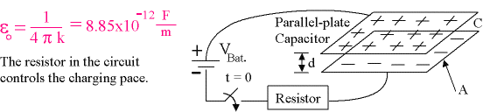

Fig. 1

In the Fig. 1, at t = 0, the capacitor is uncharged. As soon as the key in the circuit is closed, electrons flow from the negative pole of the battery toward the lower plate of the capacitor. They distribute over the lower plate, making it negative. At the same time, free electrons move off the upper plate and flow toward the positive terminal of the battery. This causes the upper plate to become positively charged. This process does not happen suddenly; it takes some time. The current is greatest to begin with, and decreases as charge accumulates on the plates. When the capacitor is uncharged at first, the voltage across it is zero, but as more and more charge builds up on its plates, its voltage keeps increasing. The voltage across the capacitor, V_{C} , asymptotically approaches the battery voltage V_{B}.
During the charging and discharging processes, the voltage across the capacitor and the current follow the following exponential equations:

(Charging)  Battery in Circuit | 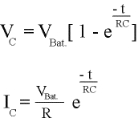 | At t = 0,  V_{C} = 0  I_{C} = V_{B} / R | As t → ∞  V_{C} = V_{B}  I_{C} = 0
(Discharging)  With battery removed, the initial capacitor voltage is V_{o}= Q₀/C making the initial current I₀ = V₀ / R | 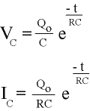 | At t = 0,  V_{C} = Q₀ / C  I_{C} = Q₀ / (RC) | As t → ∞  V_{C} = 0  I_{C} = 0

Examine the values in the third and fourth columns by setting t = 0 and t → ∞ in the appropriate equations. Note that the charge-voltage formula for a capacitor is Q = CV. These variations will be observed in this experiment

Procedure:
Arrange a circuit as shown:
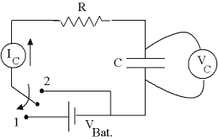

Fig. 2

If a computer is used to graph V_{C} and I_{C} versus time via an interface, there is no need for using a large capacitance, C, and a large resistance, R, in order to have a large value for the time constant
τ = RC. If voltage, current, and time are measured by three different group members, then use of large capacitance and resistance is recommended in order to have a large value for τ, so that relatively accurate measurements (readings) can be made. The two-way switch shown is put in position 1, for starting the charging process. In this case, the experimenter who keeps track of time must also close the circuit at the same time he starts measuring time. He/she must also announce the time at equal intervals. When he announces the time, two other group members read the current and voltage values. A good value for τ is 20 s, and intervals of 10 s will give each experimenter enough time to read and record a value, and concentrate on the occurrence of the next value. Obtaining 10 to 15 points for current and voltage is sufficient. The data may be exchanged between the experimenters afterwards. Do not disconnect the circuit. This is because while preparation is underway for the discharging part of the experiment, the capacitor voltage keeps increasing asymptotically toward the battery voltage.

When all members are ready for the second part of the experiment (discharging the capacitor), the timekeeper must be ready to announce the starting time and at the same time put the two-way switch in position 2 as shown in Fig. 3 below.

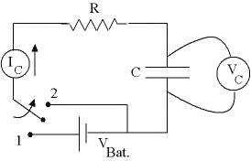

Fig. 3

The measured values may be recorded in tables as shown under the Data section.

Data:
Given:
V_{B} = the battery voltage (to be read at the starting time of charging)
V_{0C} = the initial capacitor voltage (to be read at the start of discharging)

R₁ = 500 Ω, R₂ =1000 Ω, or R₃ =4000 Ω
C₁ = 40,000 μF, C₂ = 20,000 μF, or C₃ = 5,000 μF
such that τ₁ = τ₂ = τ₃ = 20 seconds
(Use other values if decided by your instructor.)

Measured:

Capacitor Charging: (Note that the value of I_{C} at t = 0 is obvious. It is equal to V_{B}/R. Why?)

t (sec) | 0 | 10 | 20 | 30 | 40 | 50 | 60 | 70 | 80 | 90 | 100 | 110 | 120 | 130
V_{C} (volts) | 0
I_{C} (Amps) | V_{B}/R

Capacitor Discharging: (Note that the values of V_{C} and I_{C} at t = 0 are obvious. Why?)

t (sec) | 0 | 10 | 20 | 30 | 40 | 50 | 60 | 70 | 80 | 90 | 100 | 110 | 120 | 130
V_{C} (volts) | V_{oC}
I_{C} (Amps) | V_{oC}/R

Calculations:

For the charging part: I₀ = V_{B} / R

For the discharging part I₀ = V_{0C} / R

Comparison of the Results:

The accepted and measured values of τ, the circuit’s time constant, may be used to obtain a percent error. The other four graphs may be compared with the corresponding graphs in your physics book.

Conclusion: To be explained by students

Discussion: To be explained by students

